FIRST TERM MATHEMATICS NOTE FOR JSS1 2025/ 2026
Weeks | Topic
1 | Whole Numbers Counting and Writing (i) Millions (ii) Billions (iii) Trillions
2 | Whole Numbers Continued: Problems solving in quantitative aptitude reasoning using large numbers
3 | Lowest Common Multiple (L.C.M) and Highest Common Factor (H.C.F) of Whole Numbers. (a) Concept of factors and multiples (b) Concepts of L.C.M and H.C.F (c) L.C.M and H.C.F of quantitative reasoning
4 | Fractions: (a) Meaning of Fraction (b) Types of fractions (Proper & Improper) (c) Mixed numbers
5 | Fractions continued: Equivalent Fractions ( Identify and apply equivalent fractions in showing commodities and problems solving in quantitative aptitude)
6 | Fractions continued. (a) ordering of fractions (b) conversion of fractions to percentage and vice versa (c) Prime numbers and factors (d) conversion of fraction to decimal and vice versa
7 | Review of the first half term’s work and periodic test
8 | Fractions continued: Addition and subtraction of fractions
9 | Fractions Continued: (a) Multiplication and Division of fractions (b) BODMAS
10 | Estimation: (i) Concept of estimation and reasons (ii) Estimation of dimensions and reasons (iii) Estimation of capacity(volumes) and mass of objects (iv) Estimation of other things (v) Quantitative reasoning involving estimation
11 | Revision of the 1st term’s work and preparation for the first term examination
12 | First term examination

KEY TEXTBOOK: NEW GENERAL MATHEMATICS FOR JSS 1
KEY SYMBOL: NGM

WEEK ONE
TOPIC: WHOLE NUMBERS
- INTRODUCTION
1.1 Counting
To count simply means to find the quantity or number of items.

Other bases of counting: seven and sixty
7 days = 1 week
60 seconds = 1 minute
60 minutes = 1 hour
In English, ‘dozen’ means 12, ‘score’ means 20 and ‘gross’ means 144
Examples
- Find the total of 1 week 5 days, 6 days and 3 weeks 4 days. Give the answer in a. weeks and days b. just days
- Today is Wednesday. What day of the week will it be in 180 days’ time?
- Find the number of seconds in 4 mins 49 s.
- Add the following times together. Give the answers in hours and minutes. 3 h 40 min, 2 h 25 min, 28 min, 1 h 35 min.
CLASSWORK
NGM Page 2-3 Exercise 1b Nos 1, 2
ASSIGNMENT
NGM Page 2-3 Exercise 1b Nos 3-7
1.2 System of Counting
- Tally System
Tally marks were probably the first numerals.
A tally mark of 5 is written by putting a line across a tally count of 4.
i.e. = 4 and = 5
Example
Draw the tally marks for each of the following numbers:
- 37 (b) 45

CLASSWORK
NGM Page 3 Exercise 1c Nos 1-5
ASSIGNMENT
NGM Page 3 Exercise 1c Nos 6-10
- Roman numerals
The Romans used capital letters of the alphabets to represent numbers. Many people believe that the Romans used the fingers to represent numbers as follows:
I for one finger, II for two fingers, III for three fingers, V for five fingers and X for the combination of two hands (or two V’s).
The Romans also used L for fifty, C for hundred, D for five hundred and M for one thousand as shown below.
Hindu-Arabic | Roman Numeral | Hindu-Arabic | Roman Numeral
1 | I | 20 | XX
2 | II | 40 | XL
3 | III | 50 | L
4 | IV | 60 | LX
5 | V | 90 | XC
6 | VI | 100 | C
7 | VII | 400 | CD
8 | VIII | 500 | D
9 | IX | 900 | CM
10 | X | 1000 | M

The Romans used the subtraction and addition method to obtain other numerals. For example
- IV means V- I i.e. 5- 4 = 4
- VI means V+ I, i.e. 5 + 1 = 6
- IX means X- I, i.e. 10 – 1 = 9
- XXIV means XX + IV = 20 + 4 = 24
- CD means D- C = 500 – 100 = 400
- MC means M + C = 1000 + 100 = 1100

Examples
- Change the following numbers to Roman numerals: (a) 1998 (b) 2174
- Change to Hindu-Arabic numerals (a) CCXIV (b) MDCCLXIV
CLASSWORK
NGM Page 4 Exercise 1d No 2
ASSIGNMENT
NGM Page 4 Exercise 1d No 1
- The Counting board
Counters in the right-hand column (U) represent units, counters in the next column (T) represent tens, and so on.
TH | H | T | U
 |  | ●●● | ●
 | ●● | ●●●● | ●●●●
2 7 5
The diagram below is a counting board showing the number 275.
- The Abacus
An abacus is a frame consisting of beads or disks that can be moved up or down (i.e. slide) on a series of wires or strings. Each wire has its own value. Both abacus and counting board work in the same way when carrying out calculations.
Example 1
HT TT TH H T U

3
0
7
2

An Abacus showing 2703

- Place Value of Numbers
Numbers of units, tens, hundreds,…….., are each represented by a single numeral.
(a).For a whole number:
- the units place is at the right-hand end of the number.
- the tens place is next to the units place on the left, and so on

For example: 5834 means ↓
5 thousands, 8 hundreds, 3 tens, and 4 units.
See the illustration below:

5 8 3 4
(b) For decimal fraction, we count the places to the right from the decimal point as tenths, hundredths, thousandths, etc.

See the illustration below:
↓ ↓ ↓ ↓ ↓
6 . 7 9 8

6 → units
. → decimal
7 → tenths
9 → hundredths
8 → thousandths

Example 1:
What is the place value of each of the following?
- the 7 in 70269
- the 5 in 2985

Example 2:
What is the value of each of the following?
- the 8 in 2.18
- the 3 in 16.083
Example 3:
What is the value of each digit in 4 172 853?
CLASSWORK
Write down the number shown in the following figure:

NGM Page 7 Exercise 1f Nos 2, 4,7,10. Page 8 Exercise 1g, Nos 1i-1l, 4a, 4b
ASSIGNMENT
NGM Page 7 Exercise 1f Nos 1, 6,9,12. Page 9 Exercise 1h, Nos 1i-1i. 2a, 2d.

1.3 Counting and Writing in millions, billions and trillions
The figures 0, 1, 2, 3, 4, 5, 6, 7, 8, and 9 are called digits or units.
The table below gives the names and values of some large numbers.
Name | Value
One thousand | 1 000
Ten thousand | 10 000
One hundred thousand | 100 000
One million | 1 000 000=1 000 thousand
Ten million | 10 000 000
One hundred million | 100 000 000
One billion | 1 000 000 000=1 000 million
One trillion | 1 000 000 000 000=1 thousand billion
Large numbers can be read easily by grouping the digits in threes starting from the right hand side as shown below.
gap
gap
gap
three
digits
three
digits
three
digits
Billion Million TH H T U
25 800 074 4 3 0

The 1st gap separates hundreds from thousands and the second gap separates thousands from millions and the third gap separates million from billion.
Thus 25 800 074 430 reads twenty five billion, eight hundred million, seventy four thousand, eight hundred and ninety.

Examples
- Write the number 2870614275 correctly, then express it in words.
- Write 2 million in words.
CLASSWORK
NGM Page 11 Exercise 2b Nos 2,3,4,5
ASSIGNMENT
NGM Page 11 Exercise 2b Nos 6-14
Examples
Write the following in figures:
- Twelve billion, three hundred and nine million, ninety five thousand, six hundred and sixty three
- Six trillion, four hundred and thirty billion, one hundred and five million, two hundred and one thousand and fifty four
- Nine hundred and four billion, five hundred and forty million, three hundred and seventy thousand, seven hundred and fifty
CLASSWORK
Write the following in figures:
- Ninety nine million, eighty thousand, nine hundred and forty one.
- Fifteen trillion, six hundred and seventy one billion, three hundred and ninety one million, eighty eight thousand, five hundred and fifty five.
ASSIGNMENT
  - Write the following in figures:
(a) Fifteen trillion, six hundred and seventy one billion, three hundred and ninety one million, eighty eight thousand, five hundred and fifty five.
(b) Three hundred and twenty-nine billion, five hundred and sixty two million, eight hundred and one thousand, four hundred and thirty three.
  - Write in figures, the number referred to in the statement: Last year a bank made a profit of ‘two hundred and twenty billion, five hundred and one thousand, four hundred and ninety three Naira

WEEK TWO
TOPIC: WHOLE NUMBERS
2.1 Ordering Large Numbers
Any 2-digit number is larger than every unit number, e.g. 11 is larger than 9. Any 3-digit number is larger than every 2-digit number; e.g. 132 is greater than 86, and so on.
Example 1
Find the smallest and the largest number from the following set of numbers:
3 075 571, 7 108 567, 5 670 781, 3 197 859
Example 2
Arrange these numbers in order of size magnitude) starting with the smallest: 53456786, 54567432, 58479871, 24558011, 23498069, and 28478817.
CLASSWORK
- Arrange the following numbers in ascending order: 89728567, 89704567, 89693670, 89776909, and 89735890.
- Arrange the following numbers in descending order: 217679057, 497378939, 234656452, 21023404895, and 2100998969.

2.2 Using Mixture of Digits and Words with Large Numbers
Example 1
Write these numbers as a mixture of digits and words:
- 240 000 (b) ₦5 000 000
(c) 2 800 000 000 (d) 500 000 000 000
Example 2
What do the numbers in the following headlines stand for?
- Food imports rise to ₦2 billion
- Oil production now 2.5 million barrels daily
CLASSWORK
What do the numbers in the following headlines stand for?
- Floods in india - 0.65 million homeless
- New road to cost ₦$2\frac{1}{4}$trillion

2.3 Large Numbers (QR)
The S. I system of units is an internationally agreed method of measuring quantities such as length, mass, capacity and time.
Example 1.
Express the following in millimeters
(a) 123cm (b) 5.9km (c) 200m
CLASSWORK
- Change the following to the unit in brackets: (a) 5000kg (grams) (b) 1250 litres ( mL)
- NGM Page 12 Exercise 2c Nos 1a,2a
ASSIGNMENT
NGM Page 11 Exercise 2a Nos 1, 3, 4
Page 12 Exercise 2c 1b-f, 2b-f

WEEK THREE
TOPIC: LEAST COMMON MULTIPLE AND HIGHEST COMMON FACTOR OF WHOLE NUMBERS
3.1 Multiples
Multiples mean finding the product of a positive integer with another positive integer. Simply put, when a whole number multiples another whole number, the result obtained is called the multiple of either of those numbers. So a multiple is the result of multiplying factors together.
The first four multiples of 12 are
12 x 1 = 12
12 x 2 = 24
12 x 3 = 36
12 x 4 =48
Thus, we write 12, 24, 36 and 48 as the first four multiples of 12.
Note: Every whole number has an infinite number of multiples. When a number can be divided exactly by another number it means the quotient is a multiple of the divisor.
Example 1
Find the next five multiples of the following whole numbers.
(a) 4 (b) 9
Example 2
Which of the following numbers 21, 27, 24 36 and 48 are
    - multiples of 2
    - multiples of 3
    - Multiples of 4.
CLASSWORK
- Find the next 7 multiples of 12.
- Which of the following whole numbers 37, 68, 51, 128, 85 and 187 are
(a) Multiples of 2 (b) multiples of 3 (c) multiples of 5 (d) multiples of 17.
3.2 Common multiples
When two or more numbers have a multiple in common, then the numbers is known as a common multiple. Simply put, a common multiple is a multiple of two or more numbers.
Example 1
Find the first two common multiples of 4, 6 and 8.
Example 2
Write down three common multiples of the following sets of numbers
(a) 3 and 11
(b) 4, 5 and 6
CLASSWORK
NGM Page 19 Exercise 3h Nos 1, 4
ASSIGNMENT
NGM Page 19 Exercise 3g Nos 1-5
Exercise 3h Nos 2, 3, 5,6,12
3.3 Least Common Multiple (LCM)
The Least or Lowest Common Multiple (LCM) is the smallest number that two or more numbers divide evenly. To find the LCM, you can list the multiples of each number until you find a common one. For example, the LCM of 24 and 15 is 120, as 120 is the first common multiple in their lists of multiples.
An alternative method to find the LCM is using the prime factors of the numbers, which is often more efficient than listing multiples.
Example 1
Find the LCM of the following whole numbers:
(a) 24 and 15 (b) 24, 28, 36 and 50
NOTE: Given that the numbers are expressed as a product of prime factors, the LCM is the product of the prime factors of the numbers without double counting.
Example 2
Find the LCM of the following .Leave your answers in prime factors.
(a) 2 x 2 x 3 (b) 2 x 2 x 5
2 x 2 x 2 x 5 3 x 5 x 7
2 x 2 x 5 2 x 3 x 3 x 3
2 x 2 x 3 x 3 x 5 3 x 5 x 5 x 7
CLASSWORK
NGM Page 20 Exercise 3i Nos 1a, 3j
ASSIGNMENT
NGM Page 20 Exercise 3i Nos 1e, 2e, 3a, 4g, j
3.4 Factors
If a whole number divides into another number (N) without remainder, the number is a factor of N. For example:
40 $÷$ 8 = 5 and 40 $÷$ 5 = 8.
We say that 8 and 5 are factors of 40.
Example
Find all the factors of the following numbers:
- 8 (b) 40 (c) 90 (d) 100
CLASSWORK
NGM Page 15 Exercise 3a Nos 1a-1e, 2a-2e.
ASSIGNMENT
NGM Page 15 Exercise 3a Nos 1f-1j, 2f-2j

3.5 Common Factor
This is a factor of more than one number. For instance, the numbers 12, 21 and 33 are all divisible by 3. Thus we say that 3 is a common factor of 12, 21 and 33. There may be more than one common factor of a set of numbers. For instance, 2, 7 and 14 are common factors of 28, 42 and 70.
Note: every whole number has a finite number of factors.
Note: A case were you have a particular number occurring two times, duplication is not allowed. Pick it once.
Example
Find the common factor(s) of:
(1) 10 and 14 (2) 14, 24 and 38
CLASSWORK
NGM Page 17 Exercise 3e Nos 2,3,14
ASSIGNMENT
NGM Page 17 Exercise 3e Nos 4,5,6,17,18

3.6 Highest Common Factor (HCF)
It is also known as the greatest common divisor (GCD) or the greatest common factor (GCF) or highest common divisor (HCD). It is the biggest or greatest number that divides exactly into two or more numbers. For instance, 2, 7 and 14 are common factors of 28, 42 and 70 but 14 is the greatest of the three common factors. So 14 is the highest common factor of 28, 42 and 70. We will use the prime factor method in this regard.
Example 1
Find the HCF of 21 and 84.
Example 2
Find the HCF of 18, 24 and 32. Leave your answer in index form.
Example 4
Find the HCF of this. Leave the answer in prime factors and use index notation.
2³ x 5² x 7
2² x 3² x 5
3³ x 5³ x 7²
CLASSWORK
NGM Page 18 Exercise 3f Nos 1a, 2a, 3a, 4a
ASSIGNMENT
NGM Page 18 Exercise 3f Nos 1b, c 2b, c 3b, c 4f, g
3.7 PRIME NUMBERS
A prime number is a number that has only two factors, itself and 1. Some examples are 2, 3, 5, 7, 11, 13…
1 is not a prime number because it has only one factor, that is, itself unlike 2 which has itself and 1 as its factors. All prime numbers are odd numbers except 2 which is an even number.
Example 1
Write out all prime numbers between 1 and 30
9.6 Prime Factors: From our definition of prime numbers, it will be easy joining factors to it and getting the meaning of prime factors. Prime factors of a number are the factors of the number that are prime. To find the prime factors of a number. 1. Start by dividing the number with the lowest number that is its factor and progress in that order. 2. If you divide with a particular number, check if it can divide the new number again before moving to the next prime number. Example 1 Express 105 as a product of prime factors. CLASSWORK NGM Page 16 Ex. 3c Nos 1, 2, 3, 4 ASSIGNMENT NGM Page 16 Ex. 3c Nos 5, 12, 15, 16 3.8 Index Form If we have to write the following 4, 18, 16 etc. as a product of prime factors, it will pose no challenge 4 = 2 x 2 8 = 2 x 2 x 2 16 = 2 x 2 x 2 x 2
As their products increase, the challenge of how to write 2 or whichever number will be multiplying itself will arise.
A way of writing this in a shorter form is called index (or power or exponent or degree) form.
The general form is x^{n}
Where x = the base, that is the multiplicative value and
n = index or power or the number of times a particular number multiplies itself.
Example 1
Express the following index
- 9 × 9 × 9 × 9
- 5 x 5 x 5
Example 2
Express the following as a product of primes in index form.
(a) 48 (b) 136
CLASSWORK
NGM Page 17 Ex. 3d Nos 1 a, b, c, d, e, f 3 a
ASSIGNMENT
NGM Page 17 Ex. 3d Nos 3 b, c, i, l, p

WEEK FOUR
TOPIC: FRACTIONS
4.1 COMMON FRACTIONS
A fraction is a number which is represented by one integer – the numerator (the dividend) – divided by another integer – the denominator (or the divisor).
Simply put, a fraction is a part of a whole number.
4.2 GENERAL FORM OF A FRACTION
From the explanation given above, we can write fractions in the form: $\frac{a}{b}$
Where, a = the numerator
b= the denominator
Decimal Fractions
Decimal fractions are simply called decimal numbers. It has numbers to the left and right of a decimal point. e.g. 0.5, 2.5 etc

Types of Fractions (Common)
Common fractions are grouped under three headings. Because fractions are written as one integer divided by another – a ratio – they are called rational numbers.
Fractions are either proper, improper or mixed.

1. Proper Fractions: This is a common fraction having its numerator less than its denominator. Examples
(a) $\frac{5}{8}$ (b) $\frac{4}{5}$ (c) $\frac{1}{3}$ etc
2. Improper Fraction: This is a common fraction having its numerator greater than its denominator. Examples
(a$\frac{12}{5}$ (b) $\frac{7}{2}$ (c) $\frac{11}{3}$ etc
3. Mixed Numbers: This type of fraction is in the form of an integer and a fraction. That is it has two parts.
- a whole number, and
- a fraction (usually a proper fraction)
Example is shown in the figure below

From the diagram, we can describe the fraction as 1 ½ oranges
Where,
1=whole number part and
½ = fractional part

CLASSWORK
1. Give five examples each of the types of fraction
2. Using the shapes/figures below, write out the fraction stating whether it is a proper, improper or a mixed fraction.

I II

4.3 Simple Conversions
Conversions can be made from improper fractions to a mixed fraction and vice versa. Let’s see some examples.
Example 1
Express $\frac{9}{8}$ as a mixed fraction

Conversion from Mixed numbers to Improper Fraction
Let A$\frac{x}{y}$ be the general form of a mixed number, where
A = whole number part
$\frac{x}{y}$ = fractional part.
To convert to improper fraction, the following steps are followed.
1. Multiply the denominator of the fractional part by the whole number
2. Add the numerator of the fractional part to the result in (1) above.
3. Express the result in (2) above as the numerator of the improper fraction with the original denominator of the fractional part as the same denominator.

A $\frac{x}{y}$ = A $×$ y + x
y
Example 2
Express $7\frac{3}{4}$ as an improper fraction
Express $\frac{21}{8}$ as an improper fraction
CLASSWORK
NGM Page 23 Exercise 4a Nos 1a, 1m, 1s 2a, 2m, 2s.
ASSIGNMENT
NGM Page 23 Exercise 4a Nos 1b, c, d, e, t 2b, c, d, e, t.

WEEK FIVE
TOPIC: FRACTIONS
5.1 Equivalent Fraction: Two or more fractions are said to be equivalent if they have the same values. Equivalent fractions can be obtained by multiplying or dividing the numerator and the denominator by the same number.

i.Multiplication
$\frac{3}{5}= \frac{6}{10}= \frac{12}{20}$
:. The fraction 3/5, 6/10 and 12/20 are said to be equivalent fractions.
ii. Division
150 = 75 = 15
200 100 20
:. The fractions ¹⁵⁰/₂₀₀, ⁷⁵/₁₀₀ and ¹⁵/ ₂₀ are said to be equivalent fractions.
iii. Simplification: By dividing both numerator and denominator by a common factor.
44 = 22
70 35
Example 1
Find the missing numbers
(a) ¹/₃= ³/₉ = ⁶/_{A} = ^{B}/₂₄ = ⁵⁰/_{C} = ^{D}/₉₀₀ = ¹⁰⁰/_{E}
(b) ¹/₅ = ¹⁰/₅₀ = $\frac{}{100}$= $\frac{4}{}$ =$\frac{24}{}$
Example 2
Find the missing numbers.
(a) $\frac{2}{3}$ = $\frac{8}{}$

(b) $\frac{3}{5}$ = $\frac{}{15}$
CLASSWORK
NGM Page 24 Exercise 4b No 1, 2
Exercise 4c No 1b, d
ASSIGNMENT
NGM Page 24 Exercise 4b Nos 5, 6
Exercise 4c Nos 1e, f, g, h, i
5.2 Equivalent Fractions in Sharing Commodities
Problems involving sharing of commodities can be resolved with the knowledge of fractions. Some examples below will help us to understand this aspect of fraction.
Example 1
Some notebooks were shared into 18 equally. If 5 exercise books were given to Ojo, what fraction is left?
Example 2
A market woman had 90 yams. She sold ²/₃ of it. How many yam did she sell?
Example 3
Some oranges were shared out. Olu got ³/₈of them. He gave 5 to his brother and 4 to her sister and had 6 left. How many oranges were there altogether?
Example 4
In a shop, the price of a radio is reduced by one third .If the original price of the radio is ₦24, 000 what is the reduced price?
CLASSWORK
1. In a class of 40 students, ¼ are doing science subjects, ¹/₅ are doing arts and the remaining are doing commercial subjects. How many students are :( a) doing science? (b) Commercial?
2. In a service. $\frac{2}{3}$ of the people are men, $\frac{1}{2}$ are women and the rest are children. If there are 60 children, how many (a) people are there altogether? (b) More women than men are there?
ASSIGNMENT
NGM Page 26 Exercise 4f Nos 4, 5, 6,7,8,9
5.3 Problem Solving in Quantitative Aptitude
Example 1
Find the missing numbers
(a) 16 = (b) 10 =
48 3 16 8
Example 2
Reduce the following fractions to their lowest terms
(a) 5 (b) 24
100 54
Example 3
What fraction of
- 6 weeks is 6 days?
- 650m is 1km?
- 4mm is 10cm?
- 500g is 2kg?
CLASSWORK
1. Find the missing numbers
(a) 33 = 11
45 ?
(b) 9 = ?
10 90
2. Express 13 weeks as a fraction of 1 year.
ASSIGNMENT
NGM Page 31 Exercise 4m Nos 1, 2, 3,6,10

WEEK SIX
TOPIC: FRACTIONS
6.1 Ordering of Fractions
It is much easier to compare the size of fractions, when they have the same denominator.
Example 1
Which is the larger fraction: $\frac{5}{6}$ or $\frac{3}{5}$?
Example 2
Arrange the following fractions in ascending order $\frac{3}{4}$, $\frac{5}{8}$, $\frac{7}{12}$, $\frac{2}{3}$
CLASSWORK
1. Arrange the fractions in ascending order
$\frac{1}{3}$, $\frac{2}{9}$, $\frac{5}{18}$
2. Which of the following fractions is larger?
a. ²/₅ or ⁵/₇ b. ⁵/₆ or ⁴/₉
ASSIGNMENT
NGM Page 24-25 Ex. 4c Nos 2 a, b, c 3 b, c
6.2 PERCENTAGES
“Per cent’ means per hundred or ‘out of ‘hundred’ or ‘in every hundred’. Percentage is a fraction with a denominator of 100. For example, when we say a student obtained 63 percent in a test, what we mean is that he or she had 63 marks out of 100 marks. This is usually written as 63% where the symbol % means per cent.
6.2a Converting from percentage to fraction.
Here, the given value in percentage is divided by 100.
A% = $\frac{A}{100}$ in fraction or A ÷ 100, A x $\frac{1}{100}$

Example 1
Express 25% as a fraction in its lowest terms
6.2b Converting a percentage into a decimal
To convert a percentage to a fraction divide the percentage by 100.
Example 2
Change these to decimals
i. 35 % ii. $14\frac{3}{5}$ % iii. 4.5 %
6.2c Converting a fraction into percentage
To convert a fraction into a percentage, multiply it by 100.
Example 3
Express these fractions as percentages
i. $\frac{4}{5}$ ii. $\frac{75}{200}$
6.2d Converting a decimal into a percentage.
To change a decimal to a percentage, multiply it by 100
Example 4
Express the following as a percentage
a. 0.45 b. 0.025
6.2e Finding the percentage of a quantity
To find the percentage of a quantity, express the percentage as a fraction, then multiply by the quantity.
Example 5
i.4.5 % of N200 ii. 15% of N250

6.2f Expressing one quantity as a percentage of another.
To express one quantity as a percentage of another, write the first quantity as a fraction of the second and then multiply it by 100.
Example 6
i. 12 students did not do their assignments in a class of 05.
a. What is this as a percentage?
b. What percentage of the class did their assignment?
80% did their assignments.
2. What percentage of N5 is 150 kobo?
3. What percentage of 15km is 20,000cm?

CLASSWORK
1. Calculate the following:
(a) 5% of N500 (b) 18% of 144km.
2. Convert the following fraction into decimal:
(a) $\frac{4}{5}$ (b) $1\frac{2}{5}$
ASSIGNMENT
NGM Page 30 Ex. 4k Nos 1, 2,3,4,5 Ex. 4l Page 31 Nos 12, 13,14,15,16
6.3 Converting Fractions to Decimal
6.3a Terminating decimal
When the denominator divides exactly into numerator a terminating decimal is obtained.
Example 1
Change $\frac{4}{5}$ into a terminating decimal number
CLASSWORK
Change $\frac{3}{8}$ into a terminating decimal
ASSIGNMENT
NGM Page 74 Ex. 9h Nos 1,3,6,13,20
6.3b Recurring or Repeating Decimals
Sometimes when changing fractions to decimal gives the same figure or group figures repeating themselves on and on. These types of fractions are called non-terminating decimals or recurring decimals.
Example 2
a. Change $\frac{7}{9}$ to a decimal
b. Convert 0.62 to a fraction
CLASSWORK
1. Change $\frac{2}{3}$ to a decimal
2. Convert 0.376 to a fraction
ASSIGNMENT
NGM Page 75 Ex. 9i Nos 2, 3, 4, 5, 9

WEEK EIGHT
TOPIC: ADDITION AND SUBTRACTION OF FRACTIONS
8.0 Introduction
Two or more fractions can be added or subtracted immediately if they both possess the same denominator, in which case we add or subtract the numerators and divide by the common denominator.
If they do not have the same denominator they must be rewritten in equivalent form so that they do have the same denominator – called the common denominator.
The common denominator of the equivalent fraction is the LCM of the two original denominator.
In summary,
If fractions have different denominators:
- Find a common denominator by expressing each fractions as an equivalent fraction
- Add or subtract their numerators.
8.1 Addition of Fractions
Example 1: Simplify the following fractions
(a) $\frac{2}{5}$ + $\frac{3}{5}$ (b) $\frac{1}{6}$ + $\frac{3}{8}$ (c) $\frac{1}{5}$ + $\frac{1}{2}$ + $\frac{1}{4}$
Example 2: Simplify the following fractions.
- $1\frac{2}{5}$ + $4\frac{2}{3}$
- $2\frac{3}{4}$ + $4 \frac{5}{8}$ + $\frac{7}{12}$
CLASSWORK
Simplify the following:
a. $4$ + $2\frac{3}{4}$
b. $3\frac{1}{2}$ + $2\frac{1}{3}$ +$5\frac{1}{4}$

8.2 Subtraction of Fractions
Example 3: Simplify the following:
a. $\frac{11}{13}$ – $\frac{7}{13}$ b. $\frac{11}{15}$ – $\frac{3}{15}$ c. $5\frac{3}{4}$ - $1\frac{4}{5}$
Example 4: Simplify $3\frac{3}{4}$ - $2\frac{7}{8}$ +$1\frac{1}{2}$
CLASSWORK
Simplify the following:
1. $6\frac{5}{12}$ – $3\frac{3}{4}$ 2. $\frac{7}{12}$ – $\frac{3}{8}$
III. Further examples Example 1: What is the sum of $1\frac{3}{4}$ and $5\frac{4}{5}$? Example 2: A $1\frac{1}{4}$ kg piece of meat is cut from a meat that weighs $2\frac{2}{3}$ kg. What is the weight of the meat left? Example 3: A fruit grower uses $\frac{1}{3}$ of his land for bananas, $\frac{3}{8}$ for pineapples, $\frac{1}{6}$ for mangoes and the remainder for oranges. What fraction of his land is used for oranges? CLASSWORK 1. By how much is the sum of $2\frac{4}{5}$ and $4\frac{1}{2}$ less than $8\frac{1}{10}$? 2. A boy plays football for $1\frac{3}{4}$ hours, listens to radio for ¾ hours and then spends $1\frac{1}{4}$ hours doing his homework. How much time does he spend altogether doing these things?
ASSIGNMENT NGM Page 26 Ex. 4f Nos 2, 3

WEEK NINE
TOPIC: MULTIPLICATION AND DIVISION
9.0 Introduction
Multiplication of fractions is simply a direct method compared to division of fractions.
9.1 ORDER OF OPERATION (BODMAS)
When signs are combined as a result of combination of fractions, it is therefore important to apply some rules that will enable us know where to start from. Such guide is the BODMAS. It states that when there is combination of signs, they should be taken in order of their arrangement
B= bracket
O= of
D= division
M= multiplication
A= addition
S= subtraction.
Example 1
Simplify the following;
(a) $2\frac{1}{2}$ x 10 (b) $\frac{1}{2}$ of 2 ¹/₃
(c) 3¾ x $\frac{4}{9}$ x 1¹/₅ (d) $\frac{12}{25}$ of (1¼)²
Example 2
Simplify
(a) $\frac{\frac{3}{10}×\frac{35}{36}}{\frac{14}{15}}$ (b) $\frac{5\frac{1}{4} ÷ \frac{2}{5}}{3\frac{3}{4}}$

CLASSWORK
Simplify the following;
1. $\frac{8\frac{1}{6} × 3\frac{3}{7}}{11\frac{2}{3}}$
2. $\frac{7\frac{3}{7} ÷ \frac{5}{21}}{9\frac{3}{4} × \frac{2}{3}}$
ASSIGNMENT
NGM Page 28 Ex. 4h Nos 16, 17, 18
Page 29 Ex. 4i Nos 31, 32, 33, 35

9.2 Examples
Example 3
Simplify 3¾ ÷ (2¹/₇ of 11²/₃ – 5)
CLASSWORK
Simplify the following
- (9¾ - ¹/₃ ) x 4¹/₃ ÷ 3¼
- (2¾) ÷ (3¹/₃ of 2¾)
9.3 Word problems
Example 1
Divide the difference between 4¹/₅ and 2²/₃ by 1²/₅.
Example 2
What is three-quarters of 3³/₇?
Example 3
In a school, $\frac{9}{10}$ of the students play sports. $\frac{2}{3}$ of these play football. What fraction of the students play football.
Example 4
Three sisters share some money. The oldest gets $\frac{5}{11}$ of the money. The next girl gets $\frac{7}{12}$ of the remainder. What fraction of the money does the youngest girl get?
CLASSWORK
- A boy eats ¼ of a loaf at breakfast and $\frac{5}{8}$ of it for lunch. What fraction of the loaf is left?
- In a class of $\frac{4}{5}$ of the students have mathematics instrument. ¼ of these students have lost their protractors. What fraction of students in the class has protractors?
ASSIGNMENT
NGM Page 29-30 Ex. 4j Nos 5, 6, 9, 11

WEEK TEN
TOPIC: ESTIMATION
10.0 INTRODUCTION
Estimation is making guess of the nearly correct calculation in distance, weight, price or capacity of things without the actual measurement or calculation. Even though it is not accurately done, it gives a good idea of the correct answer.
Estimation help us to have a rough idea of the answer when we add, subtract, multiply or divides given quantity. Sometimes rounding off numbers and approximation are used in making estimation.
10.1 Rounding Off Numbers
To round off a number means to find an approximate value.
10.1a Rounding off numbers to the nearest value
Example 1:
Round 26505 to the nearest:
(a.) Thousand (b.) hundred (c.) ten

CLASSWORK
NGM Page 188 Ex. 23d No. 2
2. Rounding off Numbers to a Specific number of Decimal Places
Example 2:
Give 266.0956 correct to the nearest a. tenth b. hundredth c. thousandth
CLASSWORK
NGM Page 188 Ex. 23d No. 4
3. Rounding Decimal number to the Nearest Whole Number.
Example 3:
Round off 79.75 to the nearest whole number
CLASSWORK
NGM Page 188 No. 3
10.1b Significant Figures: The word significant means important and it is another way of approximating numbers. It is the leading figure or value in a number. A figure’s position in a number shows what the figure is worth.
Note: The first significant figure is always the first non-zero figure as you read a number from left. Again notice that zeros in the middle of a number are significant. Zero before or at the end of another are significant. Measurements and currencies are usually given to a specified number of significant figures.
Examples
1. Give 3457 correct to
(a) 1. s.f (ii) 2. s.f (iii) 3 s.f.
2. Give 2351.006 to
(a) 1 s.f (ii) 2 s.f. (iii) 3 s.f.
3. Give 0.007025 to
(i) 1 s.f. (ii) 2 s.f (iii) 3.s.f
CLASSWORK
1. Round off to the nearest ten: (i) 98 (ii) 327
2. Give 3.9998 to (i) 1 s.f (ii) 2 s.f
10.2 Dimension and Distances, Capacity and Mass
The common units of length (i.e. km, m, cm, mm) mass (i.e. tonne, kg, g) capacity (i.e. cl.ml) and time (hour, min. seconds) are widely used. The most common unit for length are millimetre (mm), centimetre (cm) and metre (m). Centimetre for short length and the higher units (metre and kilometre) for larger distances.
The common units of mass are the gramme (g), kilogram (kg) and tonne (t). The common units of capacity and the millilitre (ml), centilitre (cl) and litre (l) as unit length. We use the lower units for smaller quantities.
It is important to be able to choose the most appropriate metre units of measurement to use. For example to measure distances less than a metre, smaller such as millimetre (mm) and centimetres are used. To measure a large distance metres (m) and kilometres (km) are used.
For example;
i. To measure the distance between Lagos and Benin City, we use km.
ii. To measure the height of a man, we use meters and centimeter.
iii. To measure the time it will take to run 200m, we use seconds etc.
Examples
1. State the metric units at length you would use to measure the following;
(a) Length of your classroom (b) length of your fingernail
2. State the appropriate metric units of mass (weight) you would use to measure the following;
(a) Your weight (b) the weight of a diary.
3. State the appropriate metric unit of capacity you would use to measure the following;
a. the amount of water in a glass cup b. the amount of medicine in a tea spoon
4. State the appropriate metric unit of time you would use to estimate the following:
a. The time it takes a sportsman to run 100m b. the time it takes to walk or travel to your school.

CLASSWORK
NGM Page 185 Ex. 23a Nos 1a, 2a, 3a
ASSIGNMENT
NGM Page 185 Nos 1 b, c 2 i, j 3 h, i

SECOND TERM NOTE
SUBJECT: MATHEMATICS
CLASS: JSS 1
SCHEME OF WORK
WEEK 1 REVISION OF LAST TERMS WORK
WEEK 2 APPROXIMATION
WEEK 3 APPROXIMATION
WEEK 4 NUMBER BASE
WEEK 5 NUMBER BASE
WEEK 6 BASIC OPERATION
WEEK 7 REVIEW OF SECOND HALF TERMS WORK
WEEK 8 BASIC OPERATION
WEEK 9 ALGEBRAIC PROCESS
WEEK 10 ALGEBRAIC PROCESS
WEEK 11 REVISION
WEEK 12 EXAMINATION

WEEK2: APPROXIMATION
2.0 Introduction:
Approximation is the process of using rounded numbers, to estimate the outcome of calculations. Approximation can help us decide whether an answer to a calculation is right or not. We can approximate numbers by rounding them up to decimal places, significant figures, nearest whole number, tens , hundreds etc.
2.1 Decimal Place/Point:
A number such as 197.7658 is an example of a decimal number. The whole number part is 197 and the decimal part is 7658. The point between them is called a decimal point.
234.7658

Whole number Decimal part
Decimal
Point

To find the number of decimal places (d.p.) simply count the number of figures after the decimal point. Thus, the number has 4 decimal places.

197.7 6 5 8

4th decimal place

3rd decimal place

2nd decimal place

1st decimal place

Guide to round off numbers:
To round off numbers to a specific number of decimal places
1. Look for the last digit (i.e. the required decimal place you are rounding to)
2. Then look at the next digit to the right, i.e. the decider
3. If the decider is 5 or more, round up (i.e. add 1 to the last digit) if it is less than 5, round down (i.e. then add nothing).

Example 1: Give the number 85.05624 correct to (a) 1 d.p. (b) 2 d.p.
Example 2: Give 298.9945 correct to (a) 2 d.p. (b) 3 d.p.
2.2 Significant Figure:
The word significant means ‘important or non-zero digits’ and it is another way of approximating numbers. We write significant figure as s.f.

Numbers greater than zero
For example the number 865 034 has six figures or digits. The first figure from the left i.e. 8 is worth 800 000 (place value) and it is the most significant figure. It is therefore the first significant figure and 4 is the least or sixth significant figure.er
9 8 7 6 5 4

1st 2nd 3rd 4th 5th 6th

Numbers less than zero
For example 0.000007685 is given to 8 decimal places. The zero before the decimal number means that there are no units, and the 5 zeros after the decimal point mean that they are insignificant figures. Therefore the most significant number or first significant is 7 followed by 6 and 8.

0. 0 0 0 0 0 7 6 8

1sf 2sf 3sf
Note: The first significant figure is always the first non-zero figure as you read a number from the left.
Guide to round off numbers
To correct a number to a specific number of significant figures:
- Look for the required significant figure
- Look at the next significant figure to the right (i.e. the decider)
- If the decider is 5 or more round up but if it is less than 5 add nothing
Example 3: Give 7240 correct to (a) 1 s.f. (b) 2 s.f. (c) 3 s.f.
Example 4: Convert 0.00001981 to (a) 2 s.f. (b) 3 s.f.
2.3 Rounding Decimals to the Nearest, Tenth, Hundredth, Thousandths and Whole
Example 5: Give 474.4547 correct to the nearest
a. Tenth
b. Hundredth
c. Thousandth
Example 6: Round off
(a) 13.73
(b) 34.245 to the nearest whole number.
ASSIGNMENT:
NGM Page 192 Revision test 23 Nos. 3, 4, 5, 6, 7

WEEK 3:
3.1 ADDITION AND SUBTRACTION OF APPROXIMATIONS
Example 1: Approximate the following to its accuracy of degree
- 577 + 875 (2 s.f.)
- 905 + 912 (3 s.f.)
- 3076 – 621 (2 s.f.)
CLASSWORK: NGM Page 190 Ex. 23e Nos 1a, 2a, 3 a, b
ASSIGNMENT: NGM Page 190 Ex. 23e Nos 1 b,e,f,i,j,m,n,q,r 2 a,b,e,j,q
3.2 MULTIPLICATION AND DIVISION OF APPROXIMATIONS
Example 2: Round off the following to its accuracy of degree
- 672 ÷ 12 (1 s. f.)
- 5.2 × 4.5 (whole number)
CLASSWORK: NGM Page 190 Ex. 23e Nos 1 c, h 2 c, l, t
ASSIGNMENT: NGM Page 190 Ex. 23e Nos 1 l, o, p, s, t 2 d, g, p, s

WEEK 4: NUMBER BASE
4.0 Introduction:
The usual system of counting in our days is called the decimal or denary system. The denary or decimal system is also called base ten. This system enables us to be able to write small or large numbers using the combination of the digits i.e. 0,1,2,3,4,5,6,7,8,9.

4.1 Expansion and Conversion to Base Ten
Expanded Notation
Example 1: Write the following in expanded nation form.
(a) 23024₆
(b) 2001₂
4.2 Conversion to Base Ten
Example 2: Convert the numbers in example 1 to Base ten

4.3 Binary System (Base two number system)
In binary system, the greatest digit used is 1, so the two digits available in binary system are 0 and 1. Remember that each digit in a binary number has a place value.
Converting Number in Base Ten To Numbers In Base 2
We use the method of repeated or successive division to do this.
Example 3: Convert 30₁₀ to base 2.
CLASSWORK: NGM Page 196 Ex. 24c Nos 6 a, b
ASSIGNMENT: NGM Page 196 Ex. 24c Nos 6 c, d, e, f, g, h
Converting a Number in Base Two To a Number in Base Ten
We use the method of power expansion in order to solve this. You can also use the method of repeated or successive multiplication which is the converse of repeated division.
Example 4: Convert 11001₂ to a number in base ten
CLASSWORK: NGM Page 196 Ex.24c No 7 a, b
ASSIGNMENT: NGM Page 196 Ex. 24c No. 7 c, d, e, f, g, h

WEEK 5: NUMBER SYSTEM
5.1 Converting Numbers Base From One Base to Other Bases
This is a 2-stage conversion process. The steps to do this are simple. First convert the given base to base ten and then convert the result to the required base.
Example 1: Convert 2135₆ to a number in base two
CLASSWORK: Express 10111₂ to a number in base three
Example 2: Find the value of
a. (111₂)² in base two
b. square root of 11001₂ in base two
CLASSWORK: NGM Page 196 Ex.24c No 9a
ASSIGNMENT: NGM Page 196 Ex. 24c Nos 9 b, 10 b

5.2 Addition and Subtraction of Number Base
Note the following steps in adding and subtracting.
To add in base two
0+0 = 0
1+ 0 = 1
1 + 1 = 10
1 + 1+ 1 = 11
To subtract in base two
0 – 0 =0
1 – 0 = 1
10 – 1 = 1
11 – 1 = 10

Example 3: Add the following
a. 1011₂ and 1101₂
b. 101₂, 101₂, and 111₂
Example 4: Subtract
(a) 1011₂ from 1110₂
(b) 111₂ from 10101₂

5.3 Multiplication of Binary Numbers
Example 5: Find the product of
a. 101₂ and 11₂
b. 1110₂ and 101₂
CLASSWORK: NGM Page 197 Ex. 24d Nos 1 a, e, i
ASSIGNMENT: NGM Page 197 Ex. 24d Nos 1 b, c, d, f, g, h, j, k, l 2 a-l, 5

WEEK 6: BASIC OPERATION
6.1 Adding and Subtraction
When adding or subtracting numbers make sure you know the place values of the numbers. Then write each number underneath the other so that the units (U) figures are in line, all the tens (T), all the hundreds (H), and so on are in line.
Examples 6.1:
  - Add 5952 and 367
  - Take away 9397 from 16593
  - Ade has 5673 marbles, Ola has 3426 marbles, and Michael has 887 marbles. How many marbles do they have altogether?
  - Find the total of 90156, 300673, and 65489.
  - The difference between two numbers is 6032. If the larger number is 96005, what is the smaller number?

CLASSWORK:
Find the total of 53323, 42176, and 9951.
ASSIGNMENT
1. Take away 31653 from 87321
2. Find the sum of 66721, 5432, and 2255
3. Michael collected 350 oranges from her sister Helen. He gave 76 to Mathew and 121 to Kenny. How many oranges are left in Michael hands?

6.2 Multiplication and Division Of Numbers
Example 6.2:
i. Find the product of 325 and 15
ii. A big company recently bought 178 new computer each costing #195 500. How much did the company spend?
iii. Divide 2660 by 100
iv. 3002 computers are to be shared among 40 schools. How many will each school get and how many will be left over?

CLASSWORK:
Multiply the following (a) 6745 by 356 (b) 89760 by 120
ASSIGNMENT
1. Find the product of 16.55 and 2.5
2. Divide the following (a) 56748 by 24 3. 250 oranges are to be shared equally among 16 brothers. How many will each person get and how many will remain?

WEEK 8: ADDITION AND SUBTRACTION OF DIRECTED NUMBERS
8.1 INTRODUCTION
A number line is a picture of the counting numbers.
In a horizontal number line:
1. When adding, start from the first number, count right along the number line.
2. When subtracting, start from the first number, count left along the number line.
NOTE: In a horizontal number line, number to the right of zero are positive and to the left are negative.
Example 1: Use number line to find the value of (a) 1 + 4 (b) -4 – 6 (c) -9 + 12 (d) 6 – 2
CLASSWORK
NGM Ex. 12a No. 2a, b
ASSIGNMENT
NGM Ex. 12a Nos. 2c, d, e, f, 3
8.2 DIRECTED NUMBERS
Positive and negative numbers are called directed numbers. The sign tells us which direction to go from zero (0) to reach the position of the number. Zero is neither positive nor negative. As we move to the right along a number line, the numbers increase but as we move to the left, the numbers decrease.
Example 2: i. Which is the greatest number? +5, -9, +10, -2, -10, -15
ii. Arrange in order from least to greatest -5, 0, -3, -2, -7, and +5
CLASSWORK
NGM Page 94 Ex. 12d Nos 1b, c, d, e, f
ASSIGNMENT
NGM Page 94-95 Ex. 12d Nos 2, 3 b, c, d, e, f 4 b-l

8.3 ADDING AND SUBTRACTING POSITIVE AND NEGATIVE NUMBERS
A positive number is any number greater or bigger than 0 while a negative number is any number less than 0.
Example 3: Find the value of the following
- (+2) + (+3)
- (-2) + (+8)
- (+6) - (+4)
- (-3) - (+7)
- -3 - 9 + 14
- (-6) - (-10)
- 5 - (-3)
CLASSWORK: NGM Page 96 Ex. 12e Nos 1b, c, d, e, f 2b, c, d, e, f 3b, c, d, e, f
ASSIGNMENT
NGM Page 96 Ex. 12e Nos 4b, c, d, e, f 5-20
Page 97 Ex. 12f Nos 1-20
Ex. 12g Nos 1-20
Page 98-99 Ex. 12h Nos 1, 2
Ex. 12i Nos 1, 2

WEEK 9: ALGEBRAIC PROCESS
USE OF SYMBOLS / SHAPES
Algebra is a branch of mathematics in which letters of the alphabets and symbols are used in place of numbers. In other words, it is the mathematical word for generalized arithmetic.
We can use any shape to represent our letter in other to interpret the sentence very well.
Examples of shapes includes

Examples: Find the missing numbers that make the following open sentence true:
1. + 5 = 12

2. – 8 = 14

3. 12 ÷ = 3

CLASSWORK:
- 8 X 7 =
- 53 = 12 +
- 121 ÷11 =
CLASSWORK
NGM Page 34 Ex. 5a Nos 1 – 16
Examples: A. In each sentence there are two or three boxes. Put the same number in each box to make the sentence true
- + = 4

- + + = 15

B. What is the value of 5 + if 4 goes in the box?

CLASSWORK
NGM Page 34 – 35 Ex. 5b Nos 2, 3
Ex. 5c Nos 1a, 2a, 3a
ASSIGNMENT
NGM Page 34 – 35 Ex. 5a Nos 17 – 76 , Ex. 5c Nos 1 b-l, 2 b-l, 3 b-l

WEEK 10: ALGEBRAIC PROCESS
USING LETTERS TO REPRESENT NUMBERS
It is more convenient to use a letter of the alphabets to represent an unknown number instead of shapes or symbols or boxes.
The statement d + 7 = 12 is called an algebraic sentence or equation. It means d plus seven equals twelve. Thus for the sentence to be true, we must add 5. An algebraic sentence is a statement with an equals sign (=).
NOTE: The word ALGEBRA comes from an important book written around AD830 by Mohammed Musa al Khowarizmi, a noted mathematician from Baghdad. The title of the book was Al-jabr wa’l Muqãbalah.
Examples: Find the value of each letter that will make the following sentences true.
- b = 8 + 6
- s x 3 = 18
- f = 6 x 7
- p = 25 + 37
- 40 – x = x

CLASSWORK
NGM Page 35 Ex. 5d Nos 1 - 16

SUBSTITUTING NUMBERS
The value of an expression such as x+ 3 can be found by replacing x by a given number. This is called substitution.
Examples:
- Find the value of x – 9 if (i) x = 23, (ii) x = 15
- Find the value of y + 10 when y is 20
- Find the value of t + 19 when t is 45.
CLASSWORK
NGM Page 36 Ex. 5f Nos 1a, 2a, 3a

Examples: Each sentence is true. Find the number that each letter stands for
- x + x = 8
- 24 =2 k + k + k
CLASSWORK
NGM Page 36 Ex. 5e Nos 2 – 11
ASSIGNMENT
NGM Page 35 – 36 Ex. 5d Nos 17 – 76
Ex. 5e Nos 13 – 20
Ex. 5e Nos 1b – l, 2b – l, 3b-l

USING ALGEBRA FOR SOLVING WORD PROBLEMS
Remember that you can use any letters of the alphabet to represent an unknown number.
Examples:
1. What number when added to 8 gives 20?
2. Think of a number. Subtract 5 from it and the result is 15. What is the number?
3. When a number is multiplied by 5 the result is 20. What is the number?
4. A bicycle costs ₦10,000 and a radio costs ₦x. They cost ₦16,000 altogether. What is the value of x?
CLASSWORK:
NGM Page 36 Ex. 5g Nos 2, 3
ASSIGNMENT:
NGM Page 36 – 37 Ex. 5g Nos 4 - 12

SCHEMES OF WORK FOR JSS 1 THIRD TERM

WEEK 1 REVISION OF SECOND TERM’S WORK

WEEK 2 SIMPLE EQUATION

WEEK 3 GEOMETRY: PLANE SHAPES

WEEK 4 THREE DIMESIONAL SHAPES

WEEK 5 IDENTIFICATION AND PROPERTIES OF ANGLES

WEEK 6 THEOREMS

WEEK 7 REVIEW OF FIRST HALF TERM’S WORK

WEEK 8 CONSTRUCTION

WEEK 9 STATISTICS

WEEK 10 STATISTICS

WEEK 11 REVISION

WEEK 12 EXAMINATION

WEEK 2

TOPIC: SIMPLE EQUATION

2.1 INTRODUCTION

An equation is an algebraic sentence with an equals sign. The expression 3 x p= 18 is an algebraic sentence. It means three times an unknown number is equal to eighteen. We can also write this as 3x=18. So 3x=18 is an equation in x. Other examples of equations are:

y + 2 = 5, 1 = 16 – 3n

The letter or empty box in an equation is the unknown. The unknown is also a symbol in an algebraic sentence.

2.2 TRUE AND FALSE OPEN SENTENCE

A sentence such as 3x=18 may be true or false. It depends on the value of the unknown. For example, if x=6, then 3x=18 is true but if x=2, then 3x=18 is false. A sentence that may be true or false is called an open sentence.

Example: A. State whether the following are true or false
- x + 2 = 5 (when x = 3)
- 3x + 1 = 10 (when x = 2)

B. Is the equation x/4 = 5 true when x=24?

CLASSWORK

NGM Page 152 Ex. 19a Nos 1, 2, 3

ASSIGNMENT

NGM Page 152 – 153 Ex. 19a Nos 4 - 20

2.3 SOLUTION OF AN EQUATION

It is usually possible to find the value of the unknown that makes an equation true. We call this value the solution of the equation. For instance x=6 is the solution of 3x=18. To solve an equation means to find the value of the unknown(s) that makes an equation true.

Examples: Solve the following equations
- 18 – x = 7
- X + 3 = -5
- 3x = 15
- $\frac{x}{6}$ = 5

CLASSWORK

NGM Page 153 Ex. 19b Nos 1-4

ASSIGNMENT

NGM Page 153-154 Ex. 19b Nos 5-30

2.4 THE BALANCE METHOD OF SOLVING EQUATIONS

To balance an equation is to do the same to both sides. There are always two sides to an equation which are the Left Hand Side (L.H.S.) and the Right Hand Side (R.H.S.).

In using the balance method to solve equations, four things are to be considered. These are as follows:

1. Adding to both sides of the equation.

2. Subtracting from both sides of the equation.

3. Multiplying through both sides of the equation.

4. Dividing through both sides of the equation.

Examples: Solve the following equations using the balance method

1. x + 11 = 18

2. 8 = x – 5

3. y/4 = 7

CLASSWORK

NGM Page 154 Ex. 19c Nos 1-5

ASSIGNMENT

NGM Page 154-155 Ex. 19c Nos 6-30

WEEK 3: TOPIC: GEOMETRY (PLANE SHAPES AND THEIR PROPERTIES)

A plane shape is any shape on a flat surface. There are two types of plane shapes namely:

Regular and Irregular shapes.

A regular shape is a 2D shape where all (interior) angles and sides measure the same.

An irregular shape doesn’t have equal sides or equal angles.

3.1. TRIANGLES: Triangle is a three sides plane shapes with three angles.

3.1a Types and Properties of Triangles
i. Equilateral Triangles Triangles with all three sides equal in length and all three angles equal in magnitude, are called equilateral triangles. Since the angles in a triangle sum to 180° and the size of each angle is the same in an equilateral triangle, the angles are all 60°.
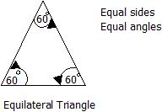
ii. Isosceles Triangles Isosceles triangles are triangles with two sides equal in length and two angles equal in magnitude.
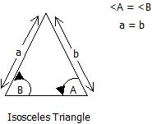
iii. Scalene Triangles A scalene triangle is one which has no sides equal in length and no angles equal in magnitude.
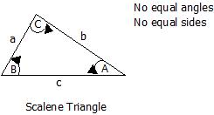
iv. Right-Angled Triangles Right-angled triangles are triangles with one of their angles equal to 90° (i.e. a right angle).
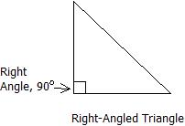

3.2 QUADRILATERALS Quadrilateral means "four sides" (quad means four, lateral means side).A quadrilateral has four-sides, it is 2-dimensional (a flat shape), closed (the lines join up), and has straight sides.

3.2a Types of Quadrilaterals There are special types of quadrilaterals:
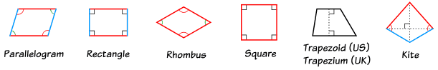
Some types are also included in the definition of other types! For example a square, rhombus and rectangle are also parallelograms. 3.2b TYPES AND PROPERTIES OF QUADRILATERALS Quadrilaterals are any four-sided figure, joined by four straight lines, that is, Quadrilaterals are four-sided polygons.
3.2bi Properties of Quadrilaterals:
-Four sides.
-Four vertices (corners).
-Interior angles sum to 360°.
-Exterior angles sum to 360°.
Things to Know:
-Diagonals are line segments that join two opposite vertices (corners).
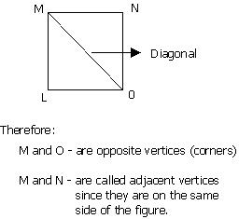

-Two sides are adjacent, if they share a common vertex.
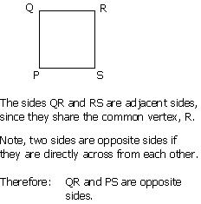
-Two angles are adjacent, if they share a common side.
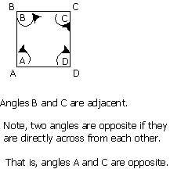

3.3 RECTANGLE
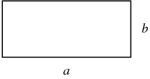
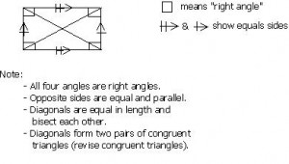Square

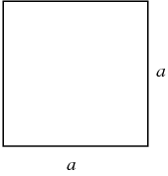
The term "square" can be used to mean either a square number (" is the square of ") or a geometric figure consisting of a convex quadrilateral with sides of equal length that are positioned at right angles to each other as illustrated above. In other words, a square is a regular polygon with four sides.
The perimeter of a square with side length a is P= 4a and the Area is A=a²
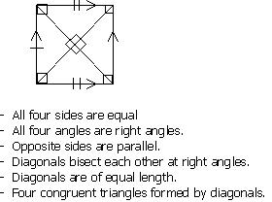

THE PARALLELOGRAM
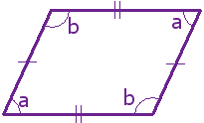
A parallelogram has opposite sides parallel and equal in length. Also opposite angles are equal (angles "a" are the same, and angles "b" are the same). NOTE: Squares, Rectangles and Rhombuses are all Parallelograms.
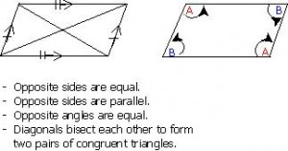Trapezium
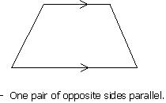
Isosceles Trapezium
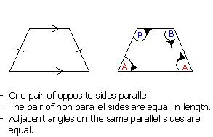
Kite
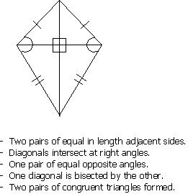

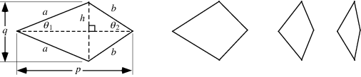
A planar convex quadrilateral consisting of two adjacent sides of length a and the other two sides of length b. The rhombus is a special case of the kite, and the lozenge is a special case of the rhombus. The area of a kite is given by

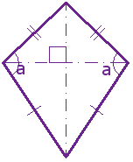It has two pairs of sides. Each pair is made up of adjacent sides (they meet) that are equal in length. The angles are equal where the pairs meet. Diagonals (dashed lines) meet at a right angle, and one of the diagonal bisects (cuts equally in half) the other.

IRREGULAR QUADRILATERALS
The only regular quadrilateral is a square. So all other quadrilaterals are irregular.
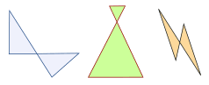

The "Family Tree" Chart
Quadrilateral definitions are inclusive. Example: a square is also a rectangle. So we include a square in the definition of a rectangle. (We don't say "Having all 90° angles makes it a rectangle except when all sides are equal then it is a square.") This may seem odd, as in daily life we think of a square as not being a rectangle ... but in mathematics it is. Using the chart below you can answer such questions as: 1. Is a Square a type of Rectangle? (Yes) 2. Is a Rectangle a type of Kite? (No)
CLASSWORK
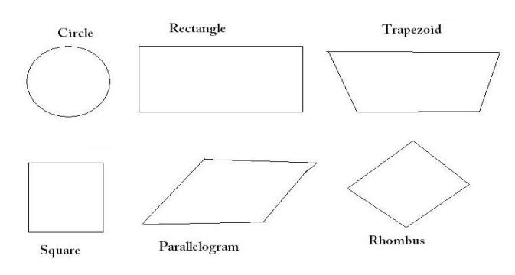
Write at least three properties each of the following shapes
WEEK 4 TOPIC: PERIMETER AND AREA OF PLANE SHAPES
4.1 PERIMETER: The perimeter of a plane shape is the length of its outside boundary or edge of a shape. This means the distance round its edges.
4.1a PERIMETER OF RECTANGLES
It is calculated as: P= 2(l + b)
Where l= length, b= breadth. Sometimes we can use the breadth as the width (w).
Examples
1. Calculate the perimeter of a football field that measures 80m by 50m.
2. A rectangle has a perimeter of 74m. Find (a) the length of the rectangle if its breadth is 17m
(b) the breadth of the rectangle if its length is 25m
CLASSWORK
NGM Page 104 Ex. 13b Nos 1a, b, c
4.1b PERIMETER OF SQUARES
It is calculated as: P= 4l
Examples
1. Calculate the perimeter of a square of side 12.3cm.
2. A square assembly area has a perimeter of 56m. Find the length of the side of the assembly area.
CLASSWORK
NGM Page 104 Ex. 13b Nos 2a, b, c
ASSIGNMENT
NGM Page 104-105 Ex. 13b Nos 1d-o, 2d-l, 3, 4, 5, 7
4.1c PERIMETER OF PARALLELOGRAMS
It is calculated as: P= 2(a + b)
Where a and b are lengths of opposite sides
Examples
1. Two sides of a parallelogram are of lengths 5cm and 8cm. Calculate the perimeter of the parallelogram.
2. The perimeter of a parallelogram is 54cm and one of its sides is 16cm long. Find the length of the other three sides.
CLASSWORK
NGM Page 105 Ex. 13b Nos 9a, b
ASSIGNMENT
NGM Page 105 Ex. 13b Nos 9c, d 11
4.1d PERIMETER OF CIRCLES
The perimeter of a circle is also known as the circumference of a circle. It is calculated as: C= 2ᴨr, where r is the radius of a circle, c is the circumference of a circle and ᴨ (pi) is the Greek letter.
But if the diameter is given instead of the radius then it will be calculated as: C = ᴨd, where d is the diameter of the circle.
NOTE: The diameter (d) is twice the radius (r). Thus, d= 2r
Examples:
1. Calculate the circumference of a circle of radius 3 1/2m. Take ᴨ as 3 1/7.
2. A bicycle wheel has a diameter of 65cm. During the journey, the wheel makes 1000 complete revolutions. How many metres does the bicycle travel? (Take ᴨ as 3.14)
CLASSWORK
NGM Page 107 Nos 2, 4
ASSIGNMENT
NGM Page 107-108 Nos 1, 3, 5, 6, 7, 12
4.2 AREA: The area of a shape is the measure of the amount of a surface it covers or occupies.
4.2a AREA OF RECTANGLES AND SQUARES
Area of rectangle= Length × Breadth (or width) or A= L × B (or W)
Suppose we are either looking for the length or breadth of rectangle, then it will be given as:
Length= Area/Breadth
Breadth= Area/Length
A square is a rectangle whose length and breadth (or width) are equal. Thus:
Area of square= (Length of side) ² or
A= l²
Therefore, Length of side= √(Area of square) or L= √(A)

Examples:
1. Calculate the area of a rectangle 6cm by 3.5cm.
2. The area of a rectangle is 224cm². If its length is 16cm, calculate the breadth.
3. Calculate the area of a square advertising board of length 5m.
4. The area of a square plot is 144m². Calculate the length of a side of the plot.
5. An assembly area is in the shape of a 30m by 30m square. Part of the area is a concrete rectangle 25m by 5m; the rest is grass. Calculate the area of the grass.
6. The area of a rectangle is 24cm² and one side is 6cm in length. Find its breadth and perimeter.
CLASSWORK
NGM Page 113-114 Ex. 14b Nos. 4, 12
ASSIGNMENT
NGM Page 113-114 Ex. 14b Nos. 1, 2, 5, 13, 14
4.2b AREA OF PARALLELOGRAMS
It is calculated as:
Area of parallelogram= base × height or A= b × h
Also, we can either find the base or height of a parallelogram as follows:
Base= Area/height
Height= Area/base
Examples:
1. Calculate the area of a parallelogram if its base is 9.2cm and its height is 6cm.
2. The area of a parallelogram is 99cm² and its base is 11cm. Calculate the corresponding height of the parallelogram.
CLASSWORK
NGM Page 115-116 Ex. 14c Nos 1a, 2a, 3a
ASSIGNMENT
NGM Page 115 Ex. 14c Nos 1b-f, 2b-f, 3b-f, 4b-f
4.2c AREA OF CIRCLES
It is calculated as:
Area= ᴨr², where r is the radius
If the diameter is given, then:
Area= ᴨd²/4, where d is the diameter
Also, Area of semi-circle= ᴨr²/2
Example:
1. Find the area of a circle of radius 14 cm. Take ᴨ as 22/7.
2. Calculate the area of a semi-circle with diameter of 14 cm.
CLASSWORK
NGM Page 120 Ex. 14e Nos 6
ASSIGNMENT
NGM Page 120 Ex. 14e Nos 1, 2, 4, 5, 8

WEEK 5
TOPIC: THREE DIMENSIONAL SHAPES
5.1a INTRODUCTION
Solid figures are often called 3dimensional shapes. A solid figure is simply anything that occupies space and also has a definite shape. A shape with no clear pattern is an irregular shape while a regular shape is a shape with a pattern. 3dimensional is having length, breadth (width) and height.
5.1b FACES, EDGES AND VERTICES
FACE: A face is the surface of a solid which is enclosed by edges.
EDGES: An edge of a solid is a line where two faces meet. Note that an edge may be straight or curved
VERTEX: A vertex of a solid is a point or corner where three or more edges meet.
ASSIGNMENT
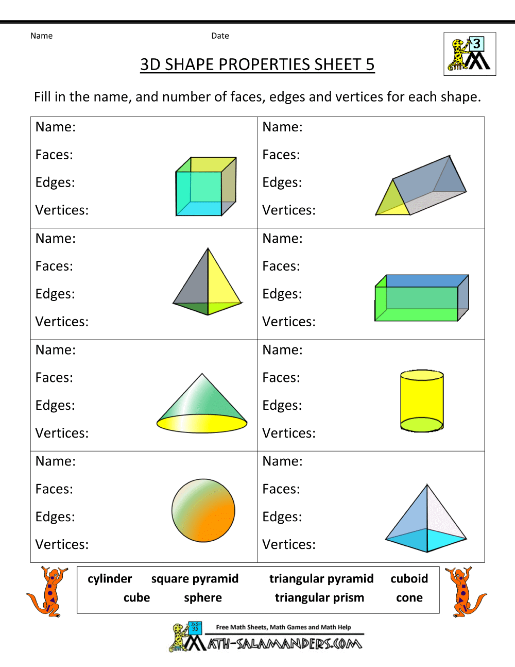
5.2 Identification and Naming of Solids.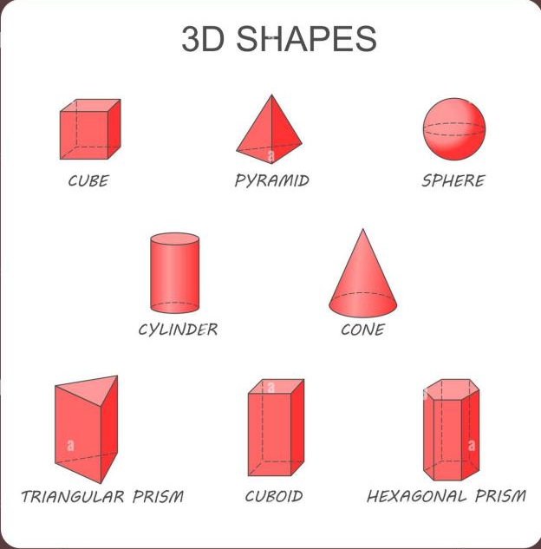
CLASSWORK
State three (3) household materials each that looks like a cone, cylinder, cube and cuboid.
5.3 Basic Properties of Prisms
A prism is a three-dimensional shape with two matching bases that are flat and parallel. The sides of a prism are rectangles that connect the two bases. Here are some basic properties of prisms:
- Two matching, parallel bases.
- Rectangular sides that connect the bases.
- The shape of the bases can be any polygon (triangle, square, etc.).
Examples includes: cube, cuboid, cylinder, triangular prism etc.
CLASSWORK
NGM Page 39 Ex. 6a Nos 1
ASSIGNMENT
NGM Page 42 Ex. 6b Nos 1, 2, 6

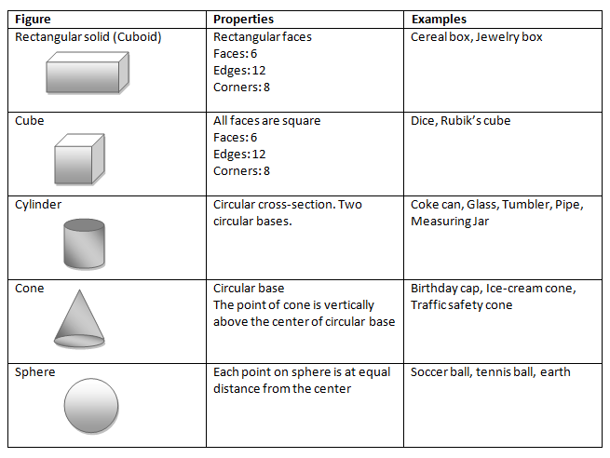
5.4 Basic Properties of Pyramids and cones
A pyramid has a flat base (which can be any shape) and triangular faces that meet at a single point called the apex. In contrast, a cone has a circular base and a smooth, curved surface that also meets at a single point called the apex. Both shapes have one flat base and come to a point at the top, but pyramids have flat, triangular sides, while cones have a curved side.
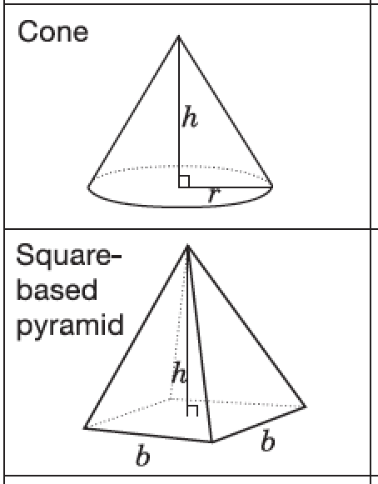
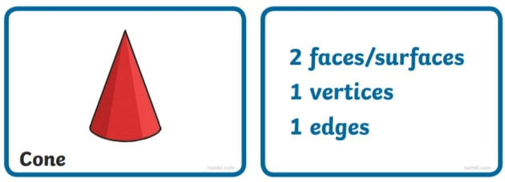
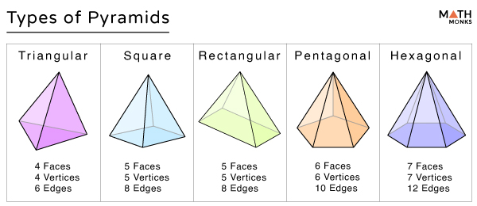
CLASSWORK
NGM Page 45 Ex. 6d Nos 1, 3, 5.
ASSIGNMENT
NGM Page 45 Ex. 6d Nos 7.

5.5 Basic Properties of Spheres
A sphere is a perfectly round ball shape where every point on its surface is the same distance from the center. This distance is called the radius. The diameter is twice the length of the radius and measures the distance across the sphere through the center.
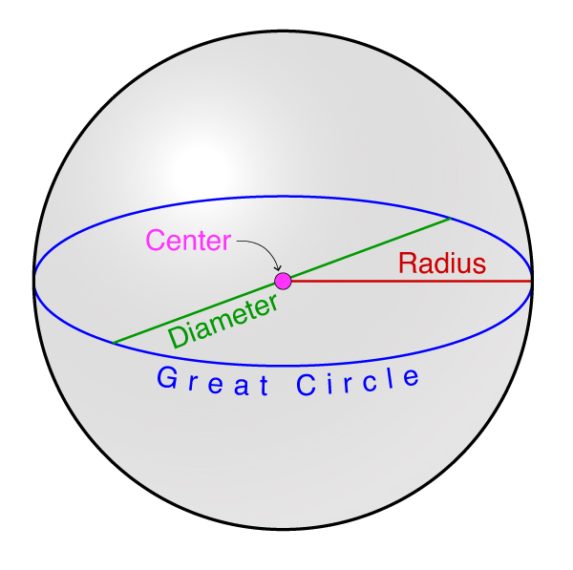
Properties of a Sphere
- Be symmetrical along all dividing axes.
- All points on the surface are equidistant from the center.
- There are no edges.
- There are no corners.
- There is a single surface, which is rounded and thus not a face (which is flat)
- The curvature of the surface remains the same along the entire surface.
CLASSWORK
NGM Page 46 Ex. 6e Nos 1, 3.
ASSIGNMENT
NGM Page 46 Ex. 6e Nos 9, 10

5.6 Net Diagrams of 3D Shapes
Net diagrams are two-dimensional representations of three-dimensional shapes. When the net is folded, it forms the 3D shape.
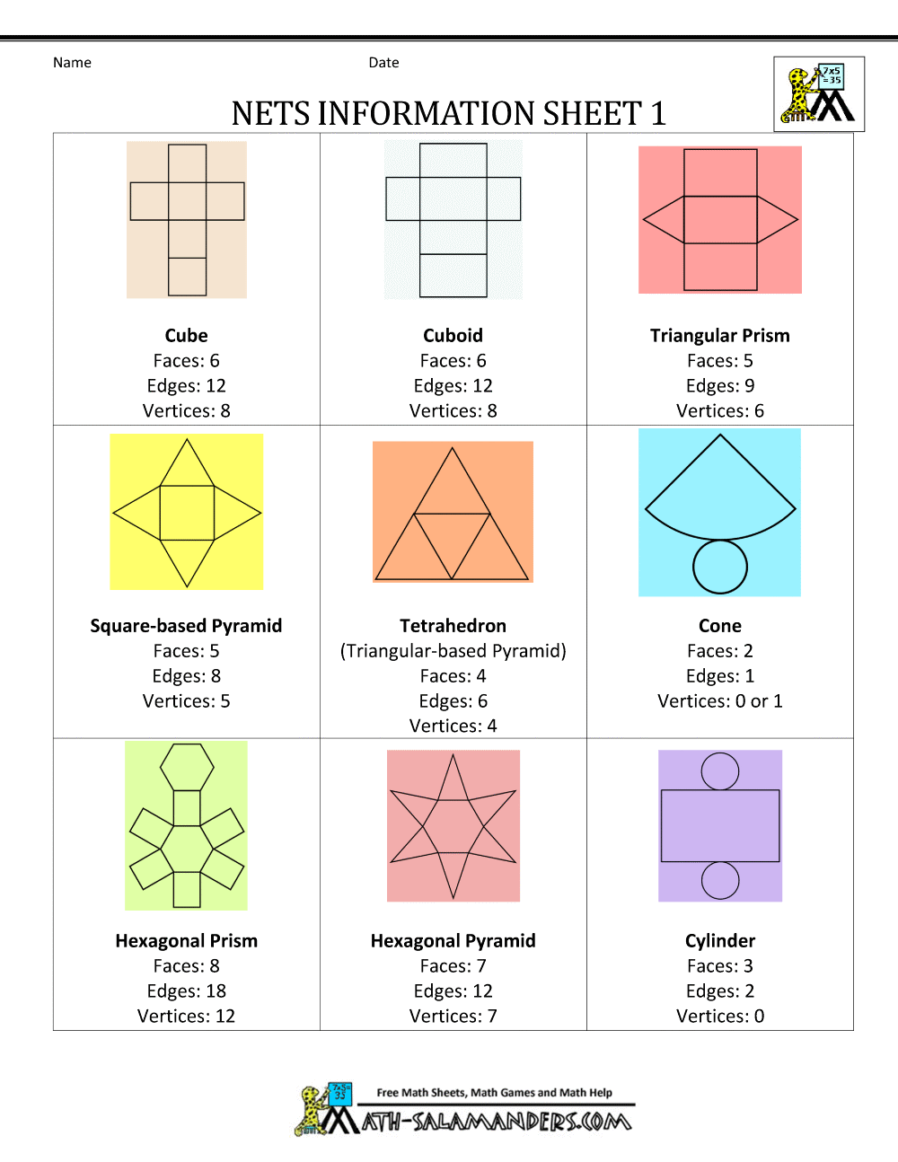
CLASS ACTIVITY
Using the net diagram above, form the following shapes with card board, scissors and glue.

WEEK 6 TOPIC: IDENTIFICATION AND PROPERTIES OF ANGLES

TYPES AND PROPERTIES OF ANGLES
Straight Angles
Angles which measure exactly 180° (degrees) are straight angles. Therefore, straight angles are straight lines. Angles are represented by the sign ϴ, called theta. That is, for straight angles, ϴ= 180°.
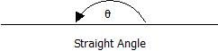
Right Angles
Angles which measure exactly 90° are right angles, that is, ϴ = 90°.
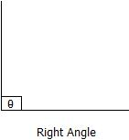
Obtuse Angles
Obtuse angles are those which are greater than 90° but less than 180°, that is, 90° <ϴ< 180°.
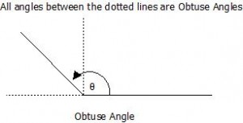

Acute Angles
Acute angles are angles which are greater than 0° but less than 90°, that is, 0° <ϴ< 90°.
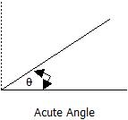
Reflex Angles
Reflex angles are angles which are greater than 180° but less than 360°, that is, 180° <ϴ< 360°.
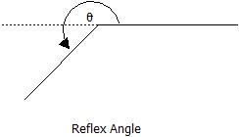
Adjacent Angles
Two angles which share the same vertex (centre, usually represented by 0) and have a common side (line) are called adjacent angles.
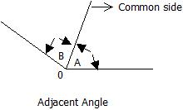

Complementary Angles
Complementary angles are two angles which when summed equals 90°.
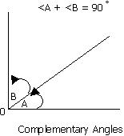
Note: <A and <B, are ‘angle A’ and ‘angle B’ respectively.
Supplementary Angles
Supplementary angles are two angles which when summed equals 180°.
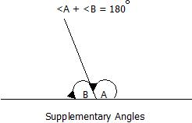
Vertically Opposite Angles
Vertically opposite angles are the angles opposite to each other when two straight lines intersect. Their defining property is that, vertically opposite angles are equal in magnitude.
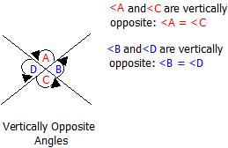
Corresponding Angles
When two parallel lines are crossed by a line called the transversal, the angles formed which are in corresponding positions, are called corresponding angles. Corresponding angles are equal in magnitude.
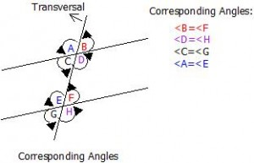

Obtuse-Angled Triangles
Obtuse-angled triangles are triangles with one of their angles greater than 90° but less than 180° (i.e. an obtuse angle).
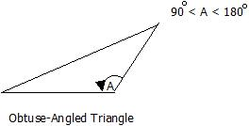
Acute-Angled Triangles
Acute-angled triangles are triangles in which all the angles are acute. That is, all angles are greater than 0° but less than 90°.
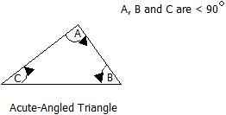
CLASSWORK
NGM Page 60 Ex. 8b No 1
Assignment: NGM Page 60 Ex. 8b No 2
WEEK 8
CONSTRUCTION
To construct a geometrical figure means to draw it accurately using geometrical instruments. Generally, to carry out a construction, you required a sharp pencil, compasses, protractor and good ruler. Other mathematical instruments or equipment such as set square, dividers and so on may also be necessary.
The ruler: is used for drawing straight line and also for measuring lengths in both centimeters and inches.
Protractor: A protractor is used for measuring and constructing angles.
Pencil: A pencil with a sharp point is used for drawing straight and curved lines. Drawing pencil may be soft or hard.
8.1 Constructing parallel lines
Steps in constructing parallel lines
- Draw the first line (Line AB): Use a ruler to draw a straight line and mark two points on it, A and B.
- Place the set square on Line AB: Align one edge of the set square with Line AB.
- Slide the set square along Line AB: While keeping the set square aligned with Line AB, slide it to the desired distance where you want the parallel line.
- Draw the parallel line: Draw a line along the edge of the set square. This new line will be parallel to Line AB.
Example 1
Draw a parallel line 3cm above /AB/= 5cm.
CLASSWORK
Draw a parallel line 4.2cm above /PQ/= 8cm.
8.2 Constructing Perpendiculars
Steps in constructing perpendicular lines
- Draw the Base Line: Use the ruler to draw a straight line on your paper. Label this line as AB.
- Place the Set Square: Align one edge of the set square with the line AB. Ensure that the right angle of the set square is positioned at the point where you want the perpendicular line to intersect AB.
- Draw the Perpendicular Line: Hold the set square firmly in place. Use the other edge of the set square (the one forming the right angle with AB) to draw a straight line. This line will be perpendicular to AB.
- Label the Intersection Point: Mark the intersection point of the two lines and label it as C. You now have a perpendicular line CD intersecting the base line AB at C.
Example 2
Draw a perpendicular line at the centre of /AB/= 5cm.
CLASSWORK
Draw a perpendicular line on /PQ/= 8cm at 3cm from point P.
8.3 Bisecting a Straight Line
To bisect a straight line using a ruler and a compass, follow these steps:
- Draw the Line: Use a ruler to draw a straight line segment AB.
- Set the Compass Width: Place the compass point on one end of the line segment (point A). Adjust the compass to a width greater than half the length of AB.
- Draw Arcs from Each Endpoint: With the compass point on A, draw an arc above and below the line. Without changing the compass width, place the compass point on the other end of the line segment (point B). Draw another arc above and below the line, intersecting the first set of arcs.
- Mark the Intersections: The arcs will intersect at two points above and below the line. Label these intersection points as C and D.
- Draw the Perpendicular Bisector: Use a ruler to draw a straight line through the intersection points C and D. This line will bisect the original line segment AB at its midpoint.
- Label the Midpoint: Mark the point where the bisector intersects the original line segment and label it as M. Point M is the midpoint of AB. Your line segment AB is now bisected at point M.
8.4 Construction of Angle 90º and 60º

Example: Construct angle 90⁰ and 60⁰.

CLASSWORK
NGM Page 176 Ex. 21d No. 1
Page 177 Ex. 21e No. 1
ASSIGNMENT
NGM Page 176 Ex. 21d No. 2
Page 177 Ex. 21e No. 2

WEEK 9

TOPIC: STATISTICS
MEANING AND USES OF STATISTICS
Statistics is the branch of mathematics which deals with the study of data. It involves
- Gathering (collecting data)
- Sorting and tabulating data
- Presenting data usually means of diagrams
- Interpreting results.
USES OF STATISTICS
- For record keeping
- To forecast or predict future events
- For planning purposes
- For decision making
- To gather information this can be passes from one source to another.
TYPES OF DATA
Qualitative data: this is non- numerical data which can only be described in words. Examples are name, place, color, sex etc.
Quantitative data: A numerical data which is usually given in form of measurement.
FREQUENCY TABLE
Example 1: The following figures show the number of children per family in a sample of 40 household. 1, 2, 4, 3, 5, 3, 5, 3, 2, 3, 4, 5, 4, 5, 4, 2, 1, 3, 2, 4.
Use a tally mark to prepare a frequency table for the data
- What is the highest frequency of numbers of children per family?
Example 2: In a further mathematics test the following marks were obtained by a group of students 15, 25, 35, 20, 75, 80, 90, 84, 95, 84, 85, 80, 80, 75, 80, 75, 80,. Use tally mark to prepare a frequency table for this data.
- How many students took part in the test?
- Which mark had the highest frequency? CLASSWORK
NGM Page 148 Ex. 18a No. 1
ASSIGNMENT
NGM Page 148 Ex. 18a No. 2

WEEK 10
STATISTICS: AVERAGE, MEAN, MEDIAN AND MODE
Average is a single value used to represent a set of numbers (i.e. all value in a set of data)
The most commonly used statistics is average.
MEAN = Sum of the value/Number of value

MEDIAN = the number at the middle after the arrangement of the data in increasing or decreasing order

MODE= the value that occurs most frequently.

Example: Calculate the mean, median and mode of the following data
- 45, 50, 55, 54, 48, 53, 50, 55
- 38, 35, 36, 30.8, 34.7, 37.9, 33.1
- 3, 0,4,7, 0, 5, 3, 4, 0, 3, 6, 5, 5 ,4, 6, 5
GRAPHICAL REPRESENTATION OF DATA
1. PICTOGRAM
2. BAR CHART
3. PIE CHART

PICTOGRAM
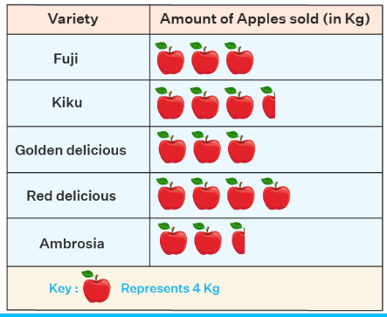

BAR CHART

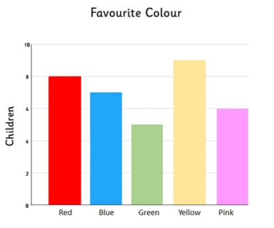
PIE CHART

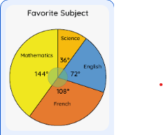

2. CLASSWORK
NGM Page 182 Ex. 22d No. 1a
ASSIGNMENT
NGM Page 182 Ex. 22d Nos. 1b-e, 2a-e

